|  |  |
| --- | --- |
| Wave a Flag *General Skills 10pts* | |
| Description:  Can you invoke help flags for a tool or binary? This program has extraordinarily helpful information... |

**Solution 1 (fast):**

1. Download the program from the description.
2. Open the terminal and use the *cd* command to navigate to the folder where the program downloaded.
3. Type in the command *cat warm*.
4. The flag can be seen in the text.

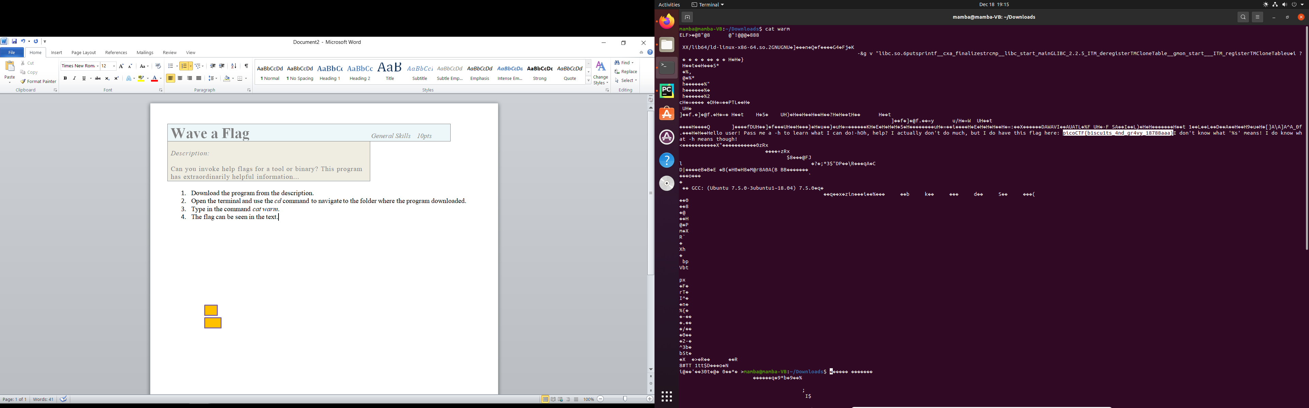

4

3

**Solution 2 (technical):**

1. Hover over the program link in the description.
   1. Copy the link to the program (you can also see it in the web-browser).

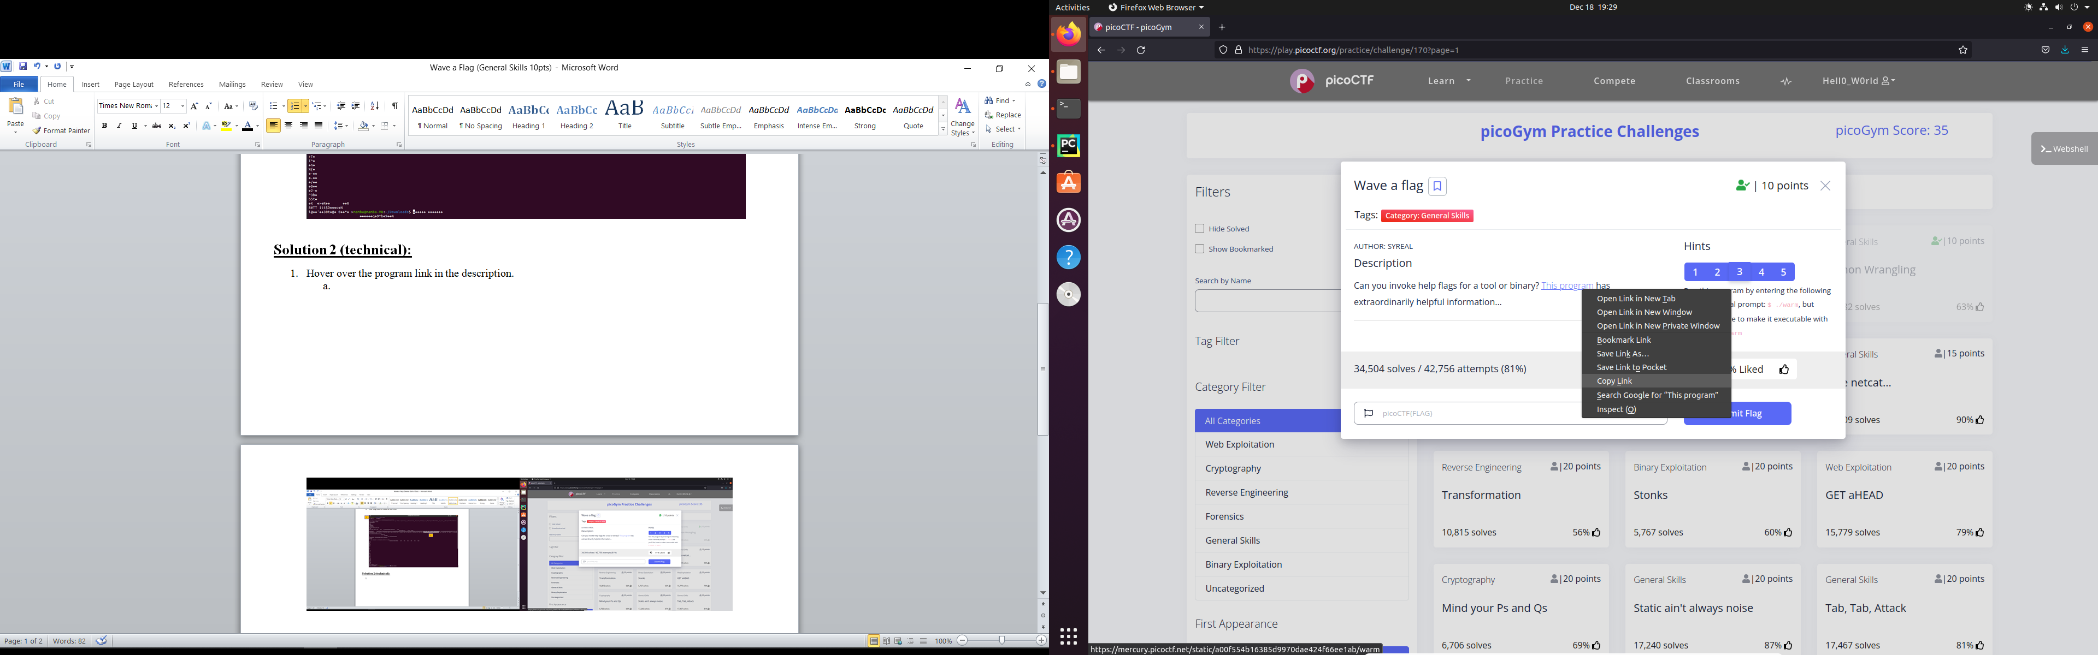

1. Open up the terminal and type in the command *wget [url from step 1]*: *wget https://mercury.picoctf.net/static/a00f554b16385d9970dae424f66ee1ab/warm*
   1. Notice the“‘warm.#’ saved*”* message.
   2. GNU wget is a computer program that retrieves content from web servers. It is part of the GNU Project. Its name derives from "World Wide Web" and "get." It supports downloading via HTTP, HTTPS, and FTP. I.e. downloads web objects.
2. Make the “warm.#” executable, by one of two ways:
   1. Use *cd* command to naviagte to downloads folder. Type in the command *chmod +x warm.#*
      1. <https://askubuntu.com/questions/443789/what-does-chmod-x-filename-do-and-how-do-i-use-it>
   2. Navigate to Downloads folder in GUI format. Right-click the “warm.#” file 🡪properties 🡪 permissions 🡪 checkmark “Allow executing file as program”
3. If not already, navigate to folder cotaining “warm.#” in terminal. Type in the command *./warm.#*
   1. A message appears that prompts you to use the *–h* command
      1. <https://www.linuxquestions.org/questions/linux-newbie-8/how-to-run-executable-files-139554/>
4. Type in the command *warm.# -h* to generate the flag.

2

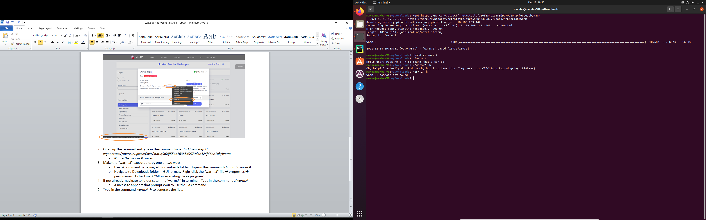

Need to use the *./* command.

3, 4, 5

2a